Question 26:

Write an HTML program to add a background-image property using URL and style tag using
external type of CSS.

Program:
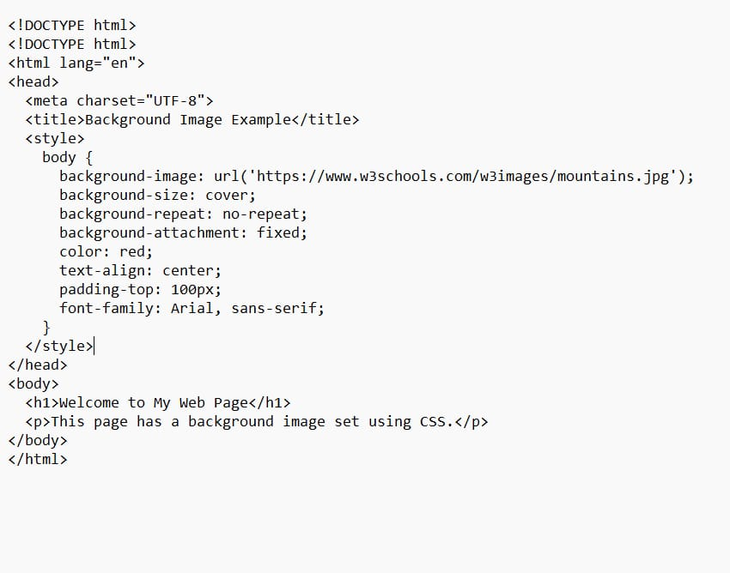

Output


